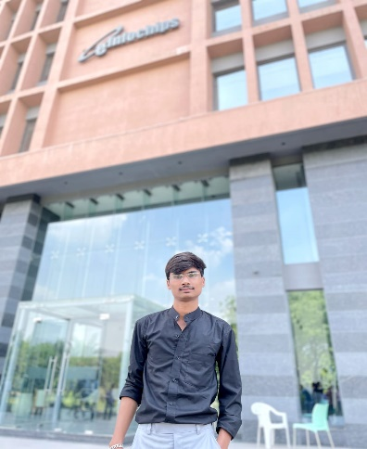

**CRM : Client Relationship Management System**

Company is widely-implemented strategy for managing the company interaction with Customer involving the technologies to organize automat and synchronize business process and activity.

**PROJECT**

* Java Backend from Tops Technologies

(Vadodara)2023-2024

* Core Java, Advance Java, Spring Framework, Hibernate, JDBC, MYSQL.

**HOBBIES**

* Cricket
* Traveling
* JAVA
* C
* C++
* MYSQL
* HTML
* CSS
* JAVASCRIPT

**CAREER OBJECTIVE**

**SKILLS**

* Good Learner
* Focused

**STRENGTH**

To get an opportunity where I can make the best of my potential and contribute to the organization’s growth.

**Date of Birth:** 16 October 2001

**Marital Status:** Single

**Gender:** Male

**TRAINING**

**EDUCATION**

2017

**10TH**

Adarsh Vidyalaya, Visnagar

2019

2022-2024

2019-2022

**Bachelor Of Computer Application (BCA)**

Hemchandracharya North Gujarat University

**12TH Commerce**

Adarsh Vidyalaya, Visnagar

**Master Of Computer Application (MCA)**

Parul University, Vadodara

**PERSONAL DETAIL**

**CONTACT**

**LANGUAGES**

* HINDI
* GUJRATI
* ENGLISH
* <https://github.com/prashantprajapati139>
* <https://www.linkedin.com/in/prashant-prajapati-0099a7257>

**WEB LINKS**

Chanakyapuri Society, Raghuvir Nagar, Anandvan Society, New Sama, Vadodara, Gujarat 390002, Vadodara, Gujarat, India – 390002

**ADDRESS**

prashantprajapati139@gmail.com

**E-MAIL**

+918511465171

**PHONE**

**Prajapati Prashant B**

**Backend Developer**